DBMS Assignment

Kunal Demla

2COE4

102003088

Assignment 1

1. Create table Student (Rno, Name, DOB, Gender, Class, College, City, Marks)

CREATE table student(RollNo Number(9),Name Char(25),DOB Date,Gender char(1),Class char(5),College char(50),City char(20),Marks number(3));

1. Insert 5 records in student table

insert into student values(102003088,'Kunal Demla','28-SEP-2002','M','COEBE','TIET','LUDHIANA',69);

insert into student values(102003087,'Gaurav Pahwa','22-APR-2002','M','COEBE','TIET','LUDHIANA',90);

insert into student values(102003089,'Sample 1','20-SEP-2001','M','COEBE','TIET','Patiala',10);

insert into student values(102003086,'sample 2','2-JAN-2000','M','COEBE','TIET','Amritsar',75);

insert into student values(102003085,'sample 3','8-FEB-2002','M','COEBE','TIET','LUDHIANA',99);

3. Display the information of all the students

select * from student;

4. Display the detail structure of student table

Desc student;

5. Display Rno, Name and Class information of ‘Patiala’ students.

Select RollNo, Name, class from student where city='Patiala';

6. Display information on ascending order of marks

Select * from student order by Marks;

7. Change the marks of Rno 5 to 89.

Update student set marks=89 where RollNo=102003085;

8. Change the name and city of Rno 9.

Update student set Name='changed', City='Jaipur' where RollNo=102003089;

9. Delete the information of ‘Amritsar’ city records

DELETE from student where City='Amritsar';

10. Delete the records of student where marks<30

DELETE from student where Marks<=30;

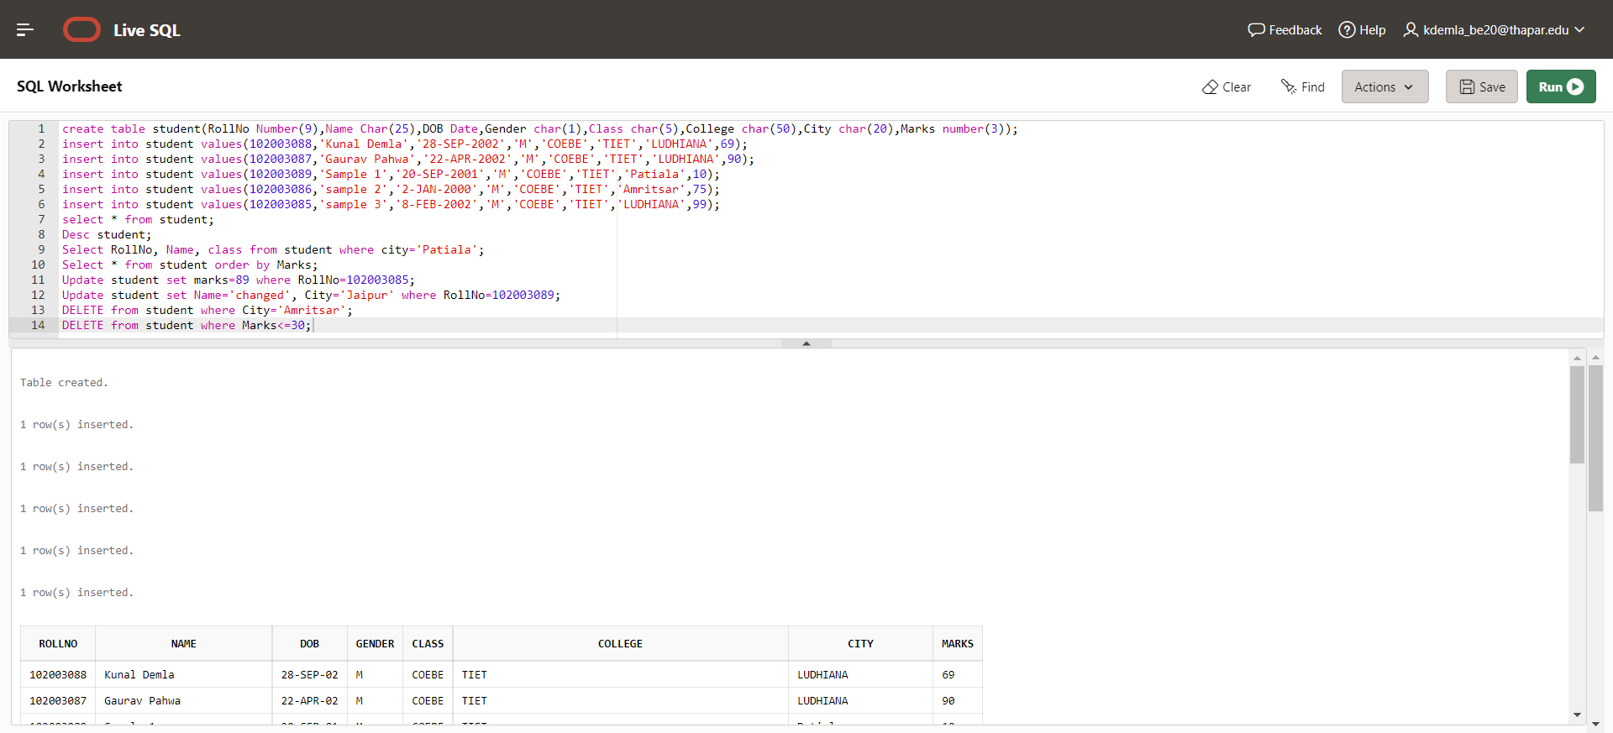

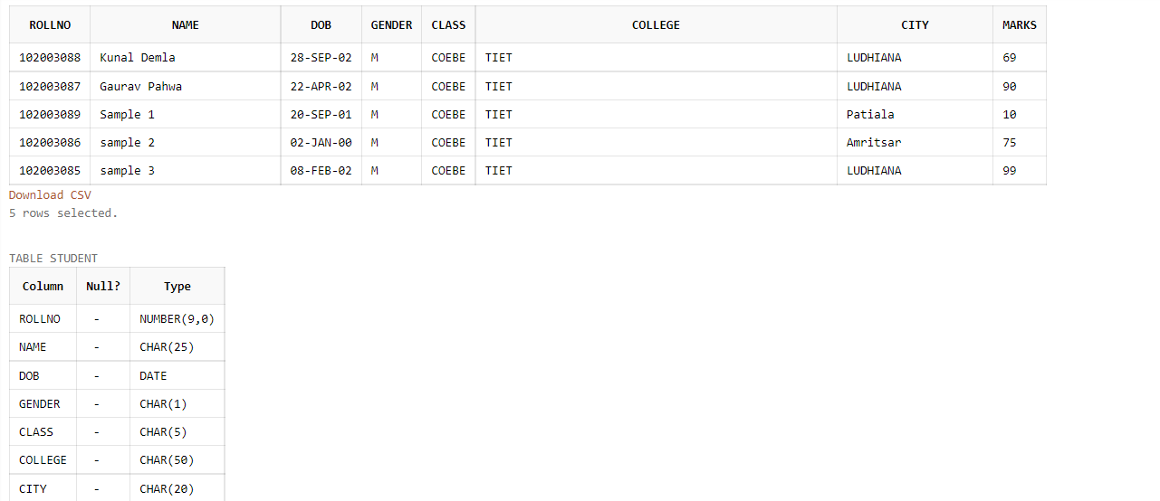

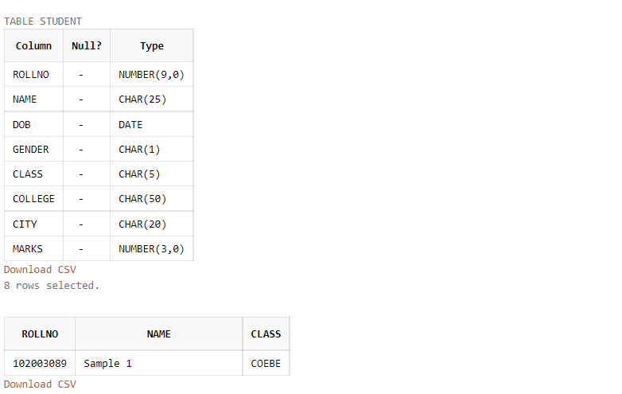

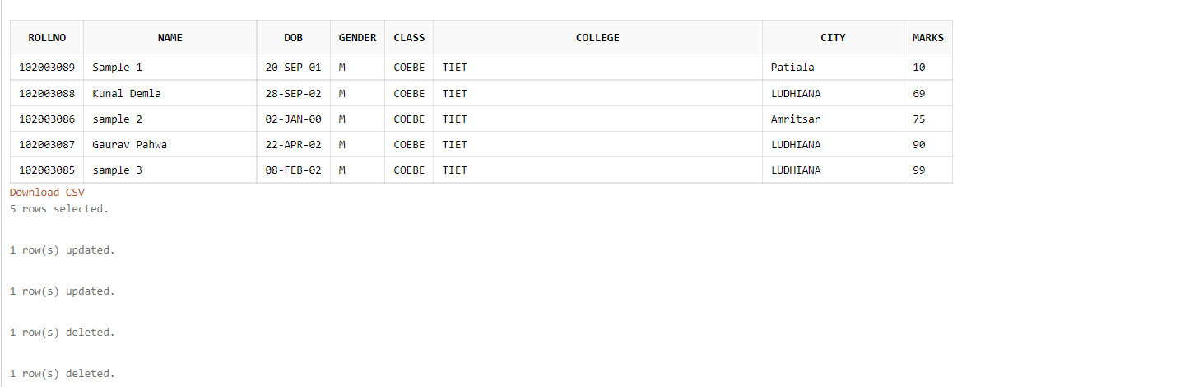

Assignment 2

1. Create table emp which has the following attributes (employee table) (empno, ename, job, sal, deptno)

create table Emp(Empno Number(5),Ename Char(25),Job Char(25),Salary Number(6),DeptNo Number(5));

2. Insert appropriate records in above tables.

Insert into Emp values(1,'Abc Xyz','Slave',200,10);

Insert into Emp values(2,'Can Grill','Manager',2500,9);

Insert into Emp values(3,'Man Ape','Monke',4200,4200);

Insert into Emp values(4,'Usain Bolt','Runner',69000,20);

Insert into Emp values(5,'Pro Art','Designer',69,69);

Insert into Emp values(6,'Boss Baby','Clerk',20000,30);

Insert into Emp values(7,'Napkin Man','Salesperson',500,40);

Insert into Emp values(8,'Alia Blyat','Failed actor',NULL,707);

3. Get employee no and employee name who works in dept no 10

Select Empno,Ename from Emp where deptno=10;

4. Display the employee names of those clerks whose salary > 2000

Select Ename from emp where salary>2000;

5. Display name and sal of Salesperson & Clerks

Select Ename,Salary from Emp where job in('Salesperson','Clerk');

6. Display all details of employees whose salary between 2000 and 3000

Select * from Emp where salary between 2000 and 3000;

7. Display all details of employees whose dept no is 10, 20, or 30

Select * from Emp where Deptno in(10,20,30);

8. Display name of those employees whose commission is NULL

Select ename from emp where salary is NULL;

9. Display dept no & salary in ascending order of dept no and with in each dept no salary should be in descending order

Select deptno,salary from emp order by deptno,salary desc;

10. Display name of employees that starts with ‘C’

Select ename from emp where ename like 'C%';

11. Display name of employees that ends with with ‘C’

Select ename from emp where ename like ‘%c’;

12. Display name of employees having two ‘a’ or ‘A’ chars in the name

Select ename from emp where ename like '%a%a%' or ename like '%A%A%' or ename like '%A%a%'or ename like ‘%a%A%’;

13. Display the name of the employees whose second char is ‘b’ or ‘B’

Select ename from emp where ename like '_b%' or ename like '_B%';

14. Display the name of the employees whose first or last char is ‘a’ or ‘A’

Select ename from emp where ename like 'a%' or ename like 'A%' or ename like '%a' or ename like '%A';

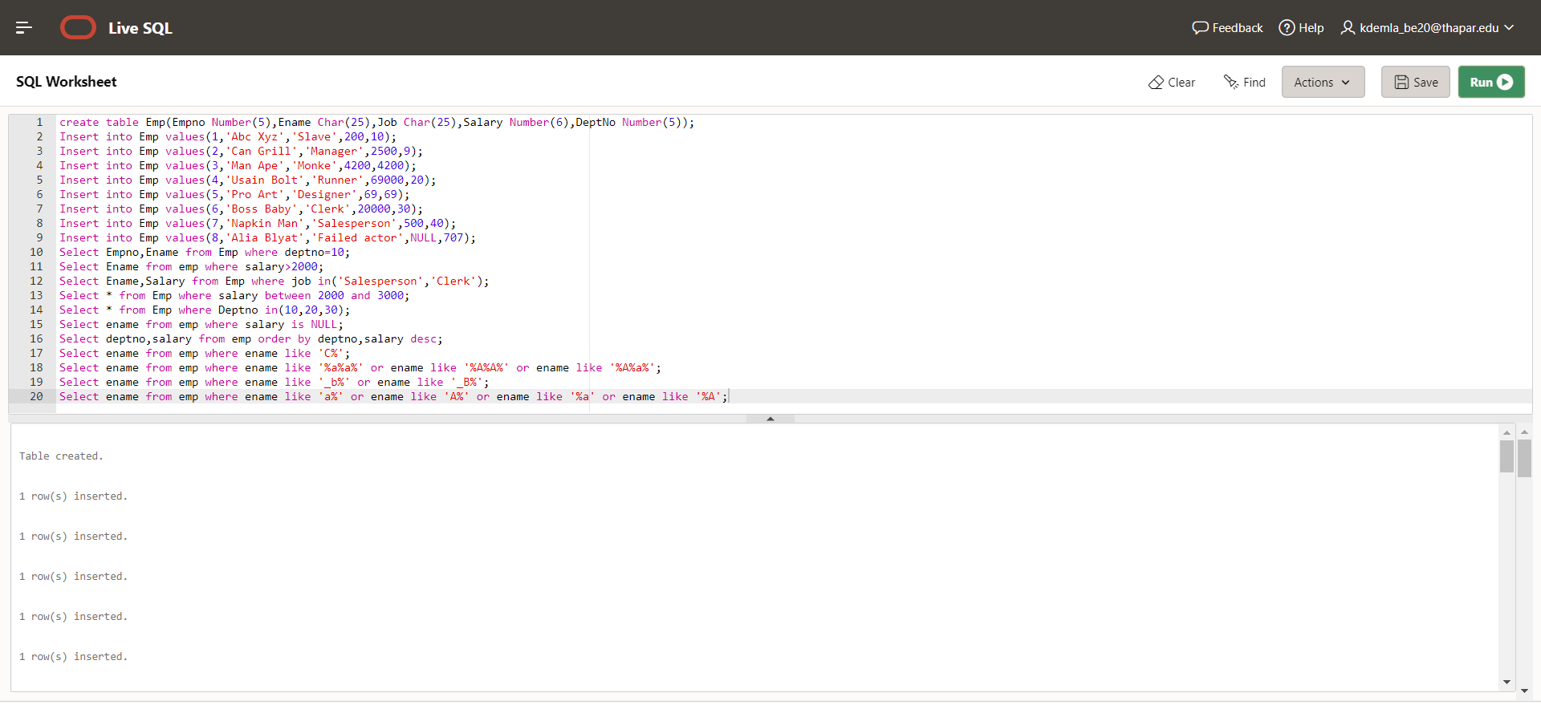

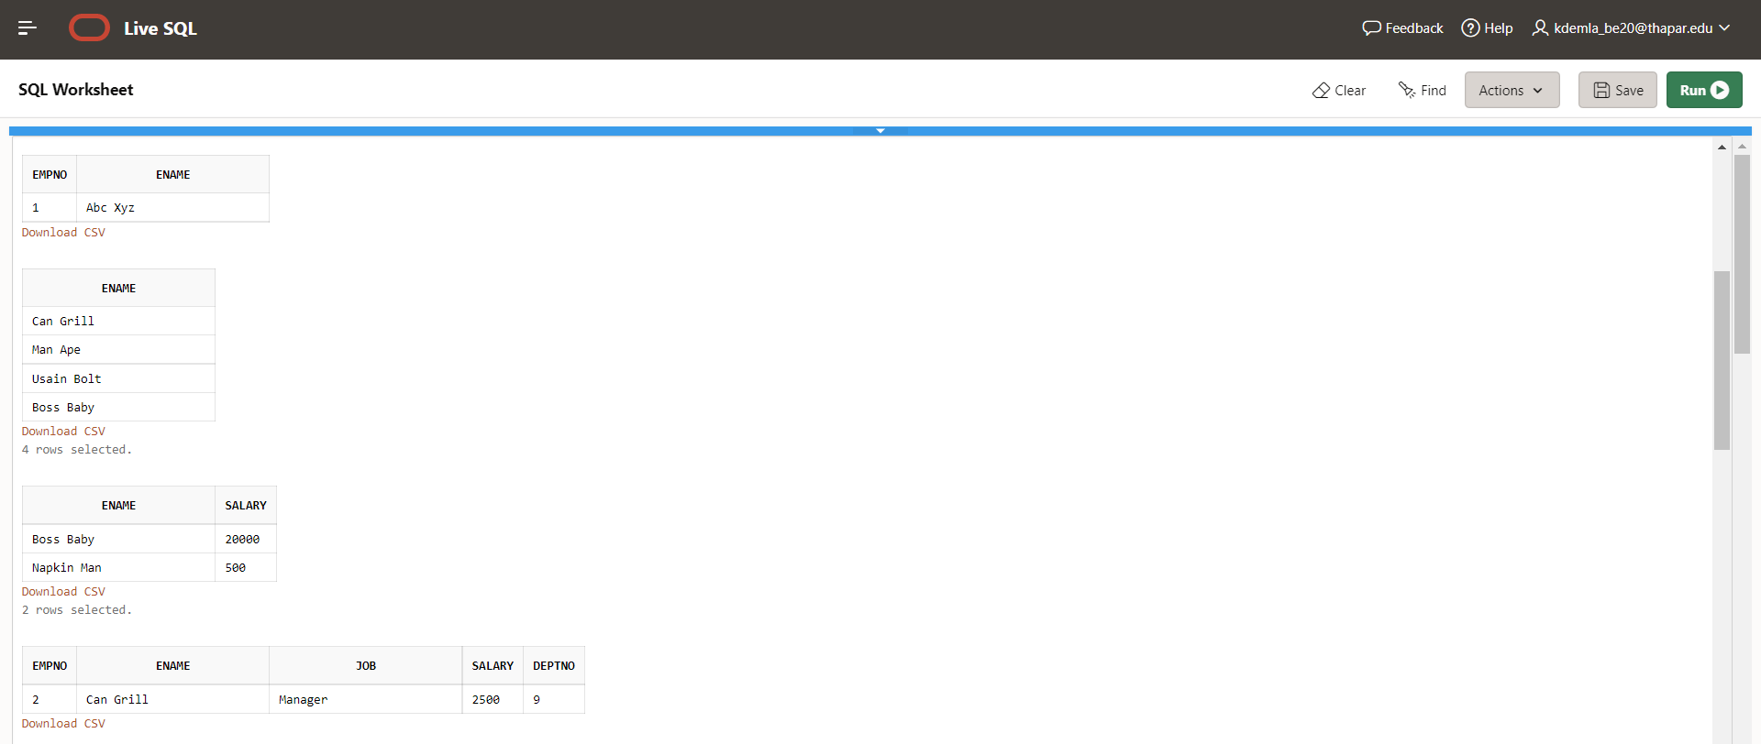

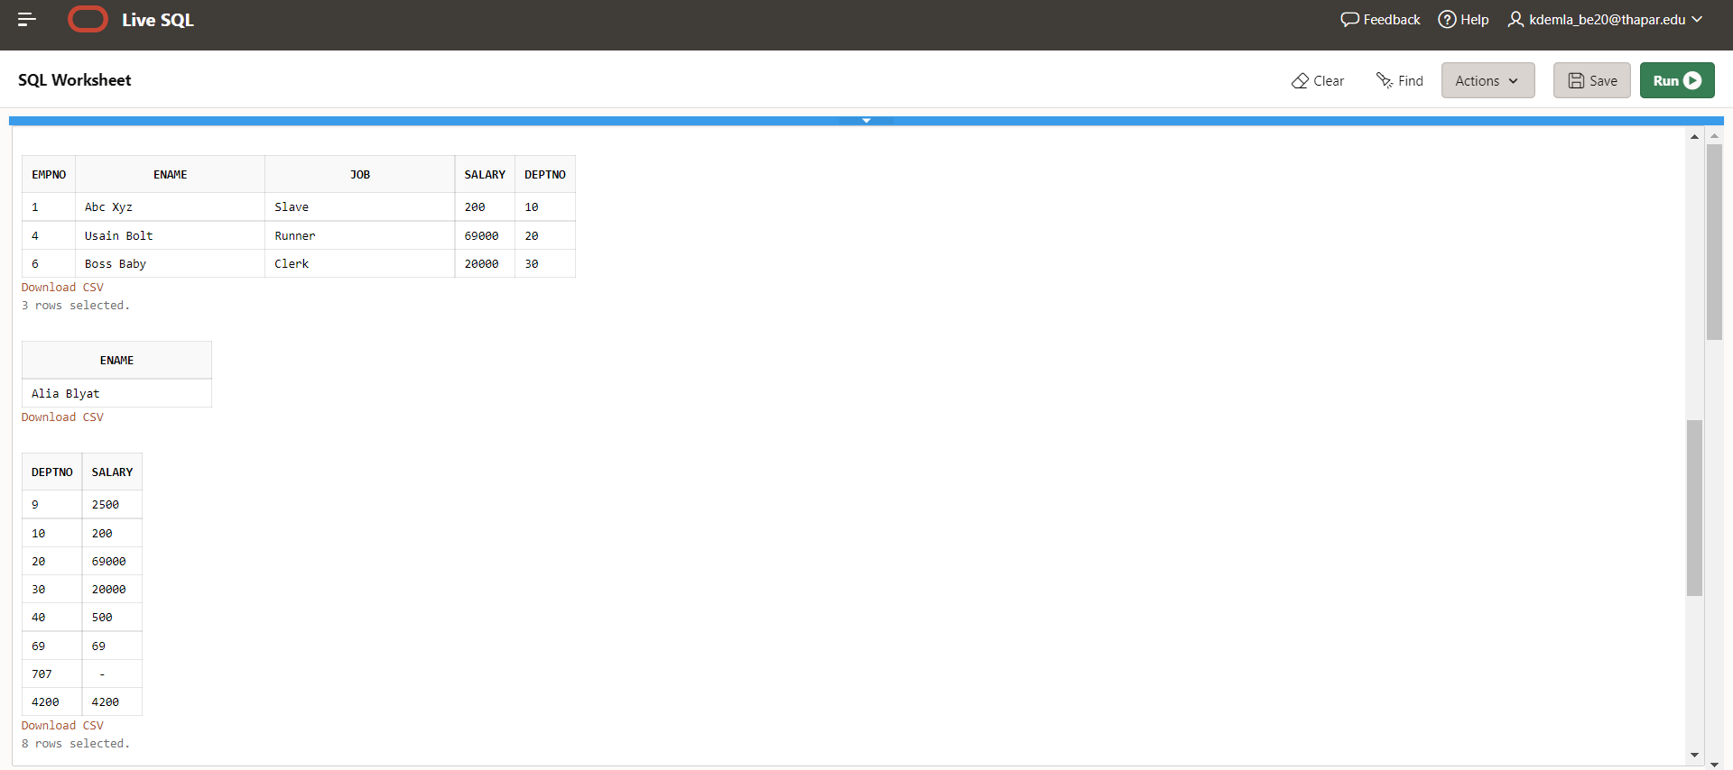

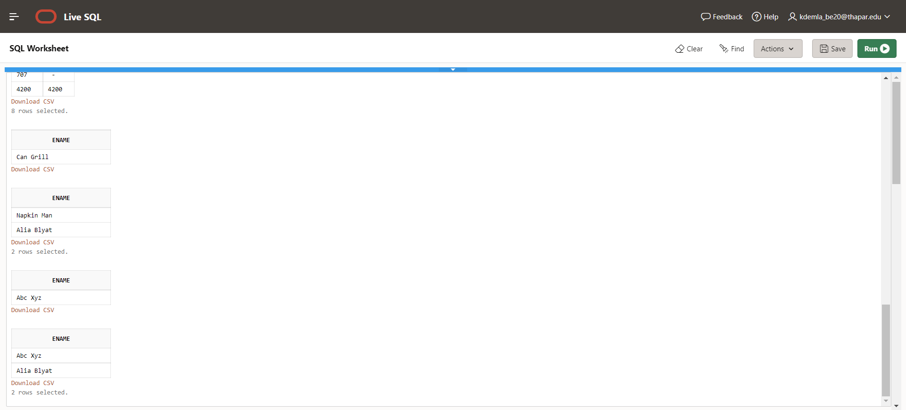s

Assignment 3

Write queries to:

1. Display the system date

select SYSDATE from dual;

2. Display current day

select to_char(SYSDATE,'Day')CURRENT_DAY from dual;

3. Display current month and spell out year

select to_char(SYSDATE,'Month')Month, to_char(SYSDATE,'YYYYSP')Year from dual;

4. Display spell out current date

select to_char(SYSDATE,'DDSP')curr_date from dual;

5. Check whether it is AM or PM right now

select to_char(SYSDATE+0.22916,'AM') from dual;

6. Display the date of next Friday

select next_day(SYSDATE,'FRIDAY') from dual;

7. Round the system date on month

select ROUND(SYSDATE,'MM') from dual;

8. Truncate the system date on month

select TRUNC(SYSDATE,'MM') from dual;

9. Round the system date on year

select ROUND(SYSDATE,'YEAR') from dual;

10. Truncate the system date on year

select TRUNC(SYSDATE,'YEAR') from dual;

11. Find the day after three days

select TO_CHAR(SYSDATE+3,'DAY') from dual;

Queries Based on EMP table

12. Display day of date of joining column

Select to_char(Date_Of_Join,'DAY') from emp;

13. Display those employees who join the company on Monday

Select * from emp where to_char(Date_Of_Join,'DY')='MON';

14. Display those employees who join the company this month

Select * from emp where to_char(Date_Of_Join,'MON')=to_char(SYSDATE,'MON');

15. Display those employees who join the company in last 30 days

Select * from emp where (SYSDATE-Date_of_Join)<=30;

Create a table train having three four columns

16. Train Number, date of Departure, time of departure, time of arrival

CREATE TABLE train(Train_Number number(5), date_of_Departure date, time_of_departure timestamp, time_of_arrival timestamp);

17. Insert five columns in train table

insert into train values(10001, '22-JAN-2022', '22-JAN-2022 11:45:00','22-JAN-2022 11:30:00');

insert into train values(10002, '22-SEP-2022', '22-SEP-2022 1:45:00 PM','22-SEP-2022 1:30:00 PM');

insert into train values(10003, '24-SEP-2022', '24-SEP-2022 11:45:00 PM','24-SEP-2022 11:30:00 PM');

insert into train values(10004, '23-FEB-2022', '23-FEB-2022 11:50:00','23-FEB-2022 12:30:00 PM');

insert into train values(10005, '21-JAN-2022', '23-FEB-2022 11:00:00','23-FEB-2022 11:15:00');

18. Display all the records

select * from train;

19. Display the time values inserted in the columns

select time_of_arrival,time_of_departure from train;

20. Display those trains which arrived on PM

select * from train where to_char(time_of_arrival,'PM')='PM';

21. Display train number who are going to depart in next on hour

select Train_Number from train where time_of_departure<(sysdate+0.27083) and time_of_departure>(sysdate+0.22916);

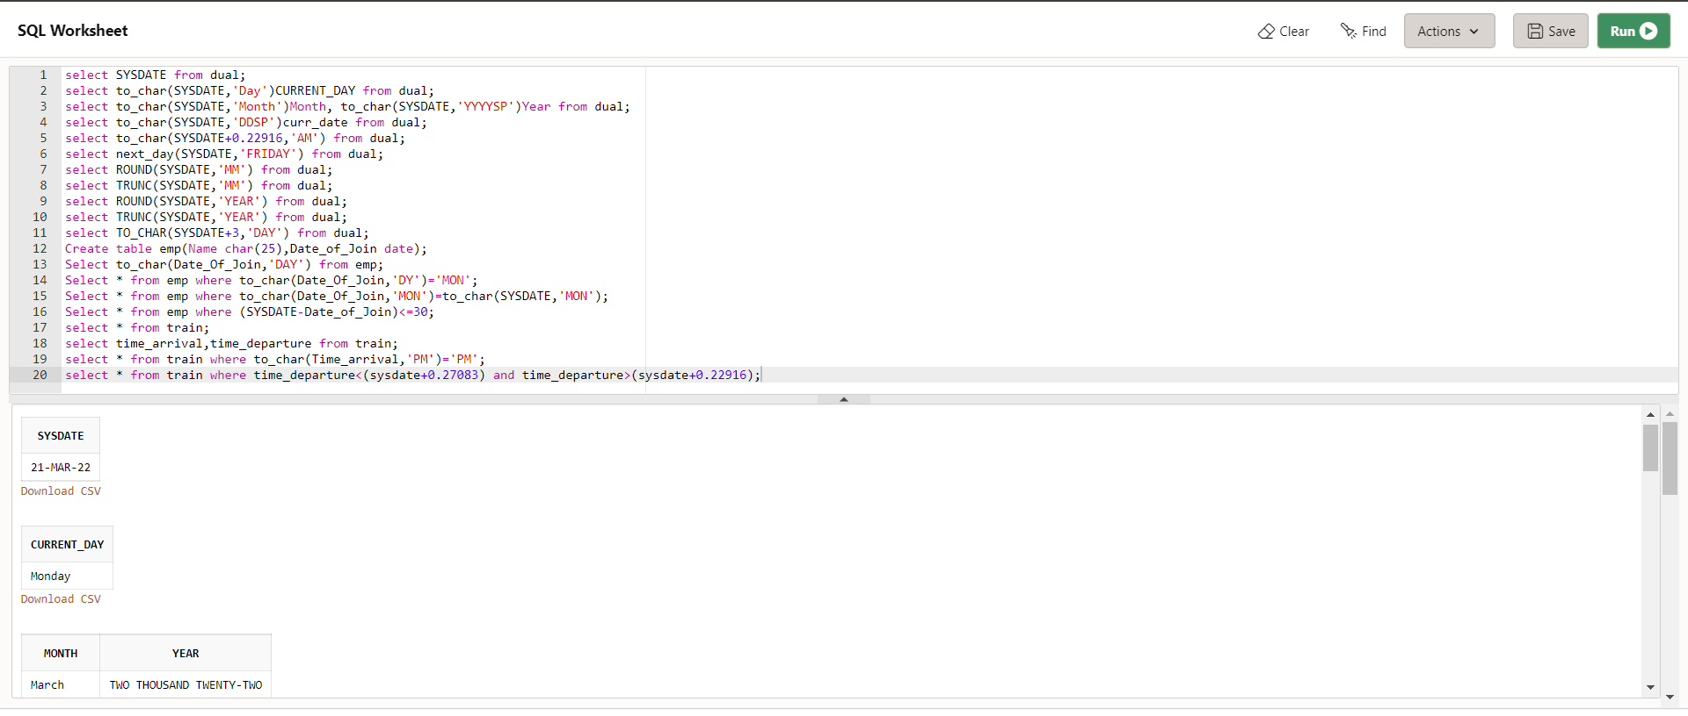

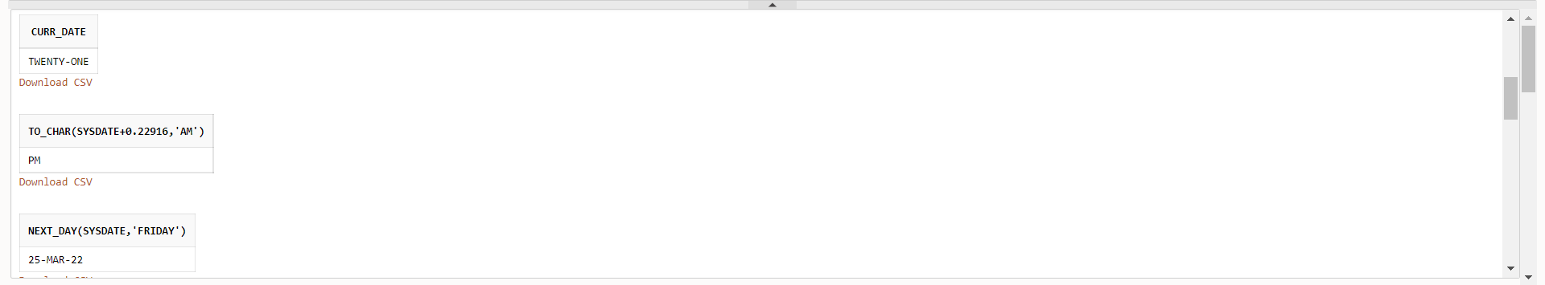

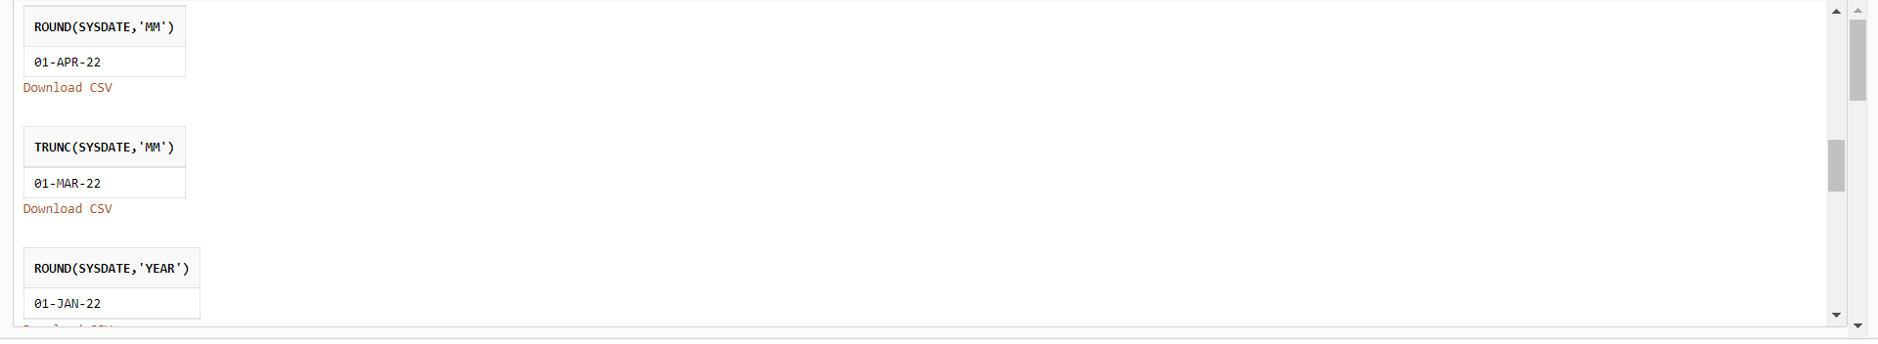

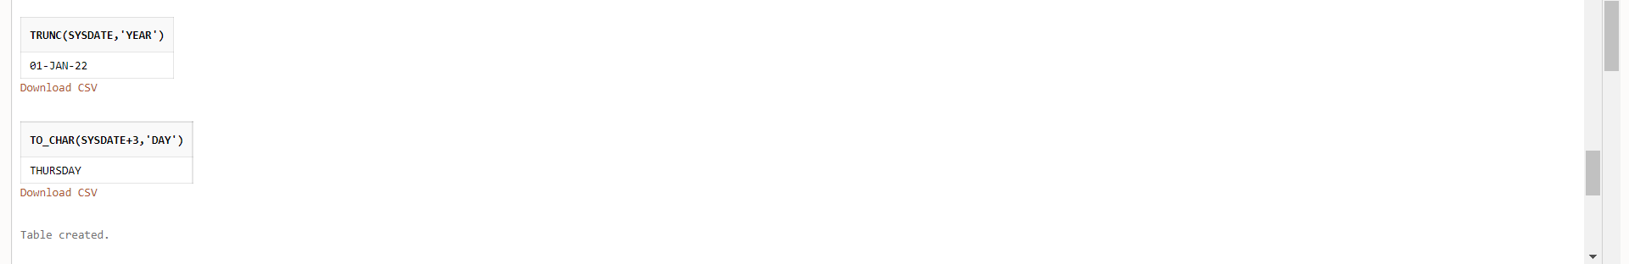

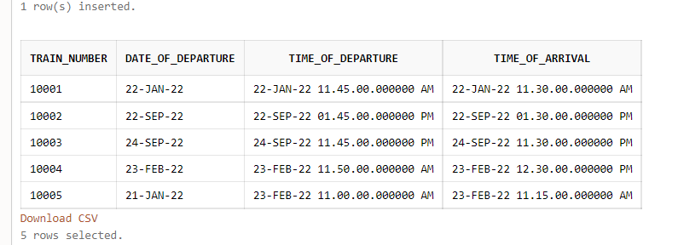

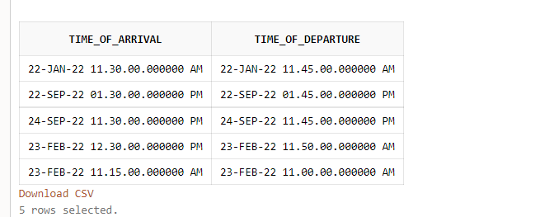

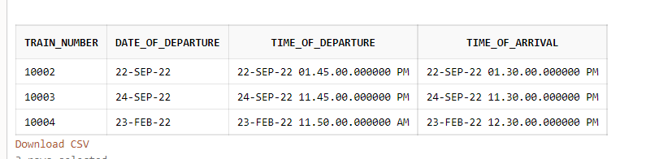

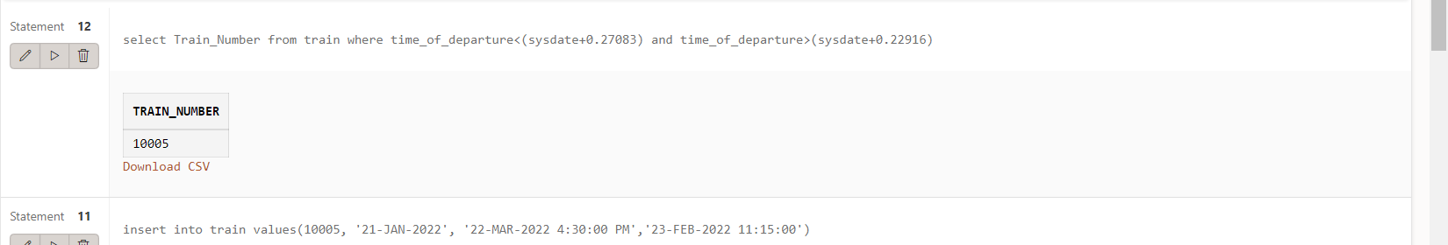

Assignment 4

Q1) Use the following functions →

1. chr (n):

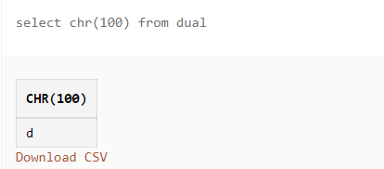

2. cancat(char1,char2):

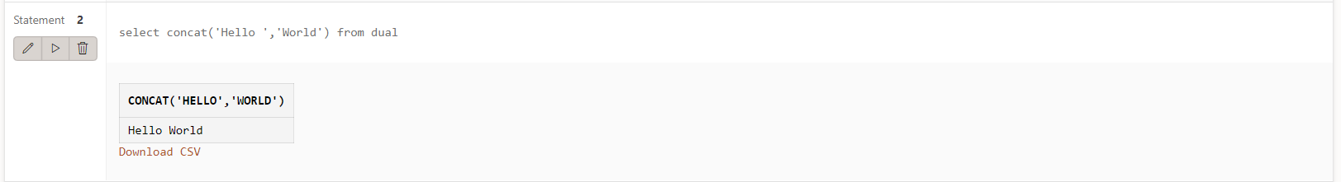

3. instr(string,char):

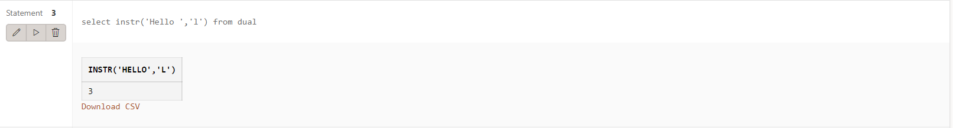

4. length(n):

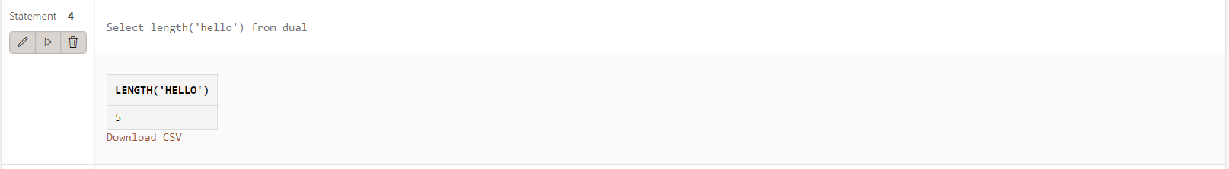

5. lpad(char1 ,n [,char2]):

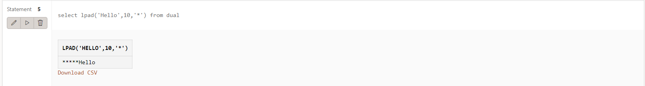

6. ltrim(string [,char(s)]):

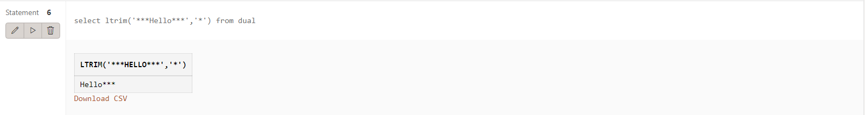

7. rpad(char1 ,n [,char2]):

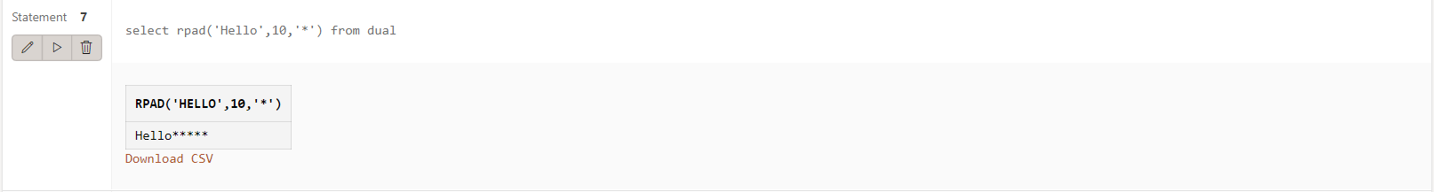

8. rtrim(string [,char(s)]):

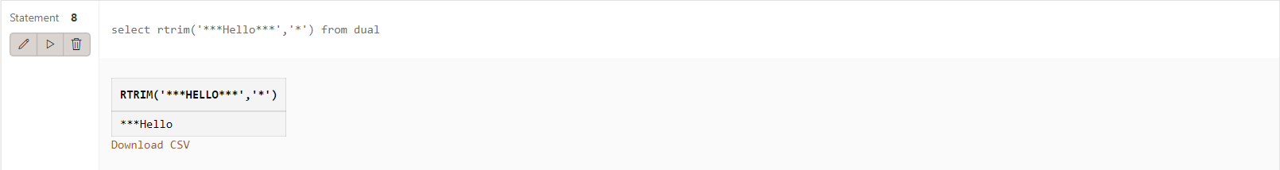

9. replace(char ,search_string , replacement_string):

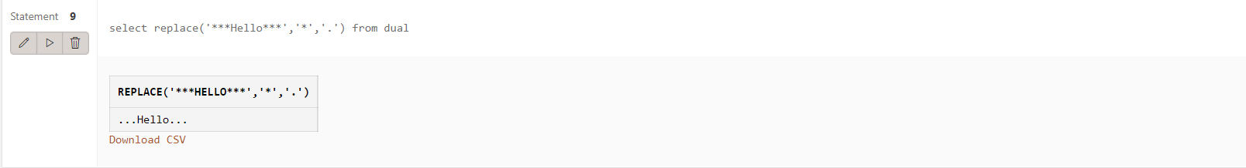

10. substr(string ,position ,substring length):

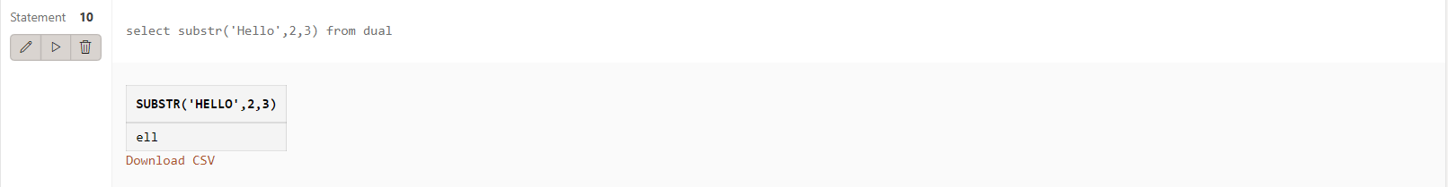

11. initcap(char):

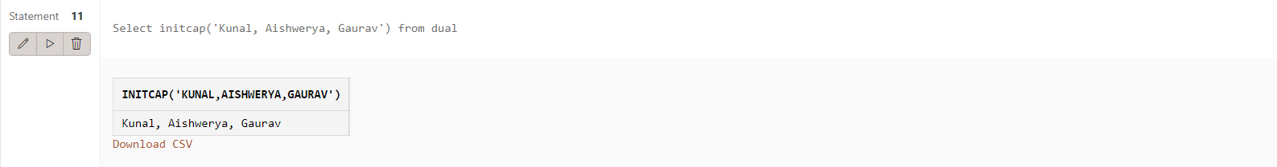

12. lower(string):

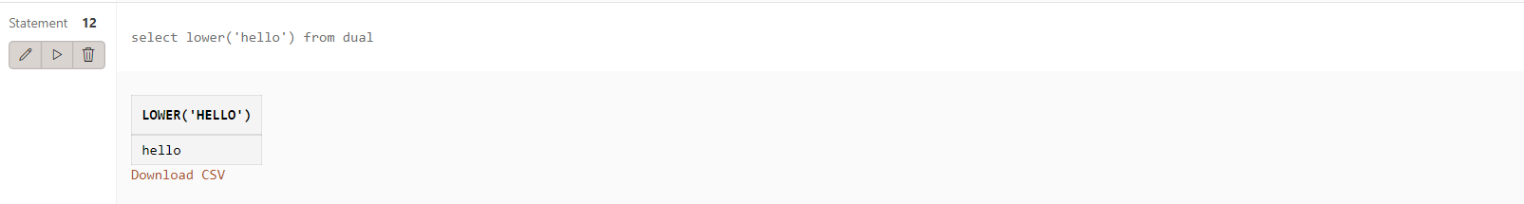

13. upper(string):

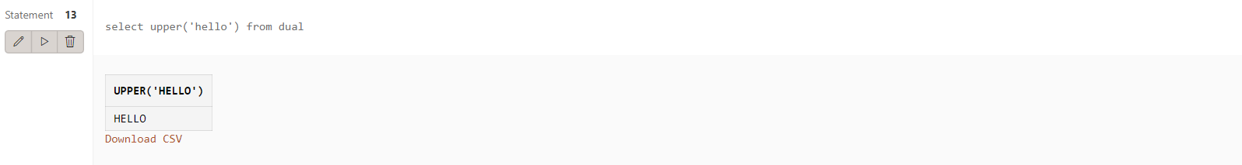

14. translate(char ,from string ,to string):

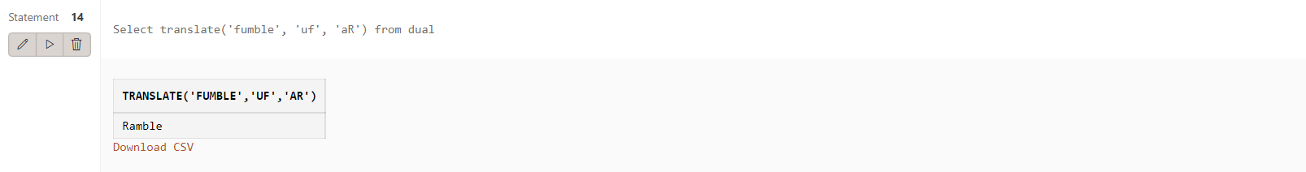

15. abs(n):

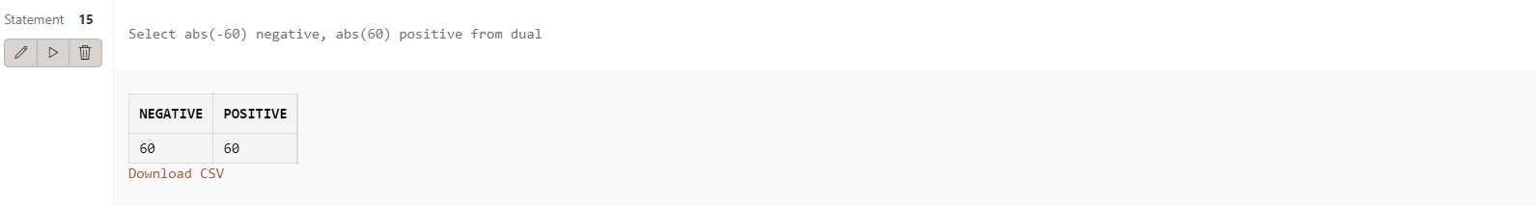

16. ceil(n):

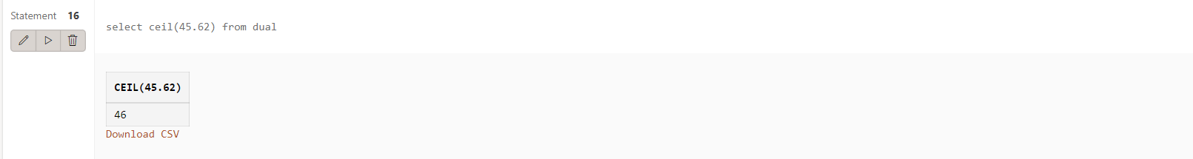

17. cos(n):

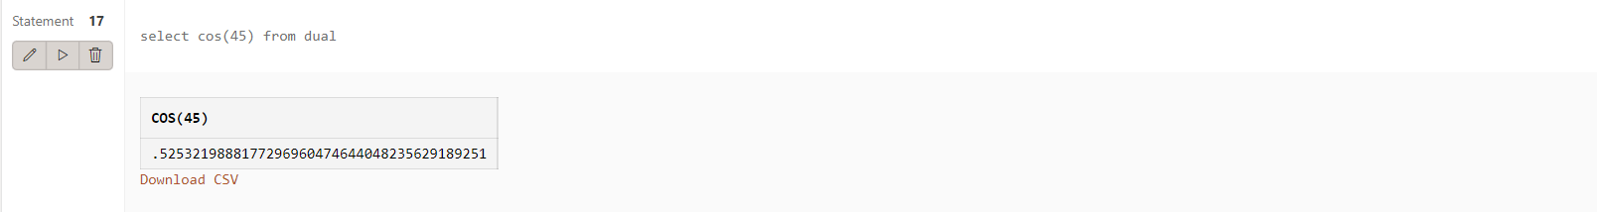

18. exp(n):

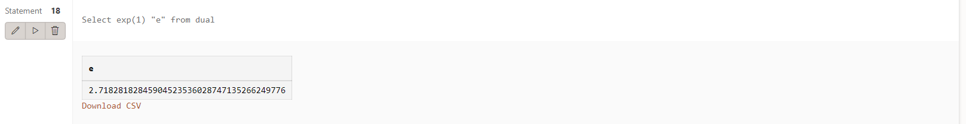

19. floor(n):

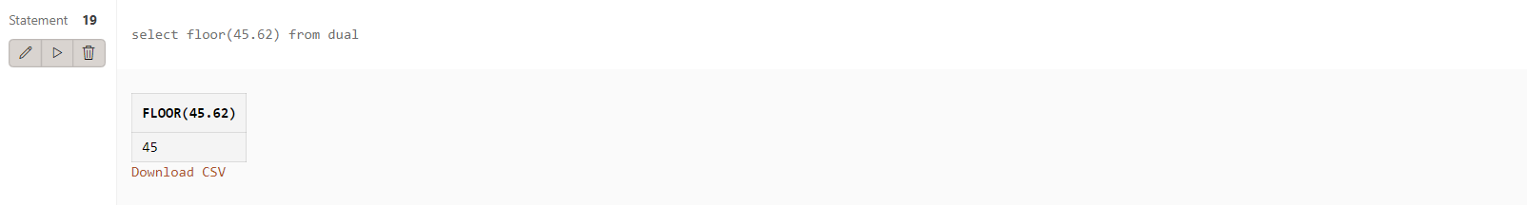

20. mod(m ,n):

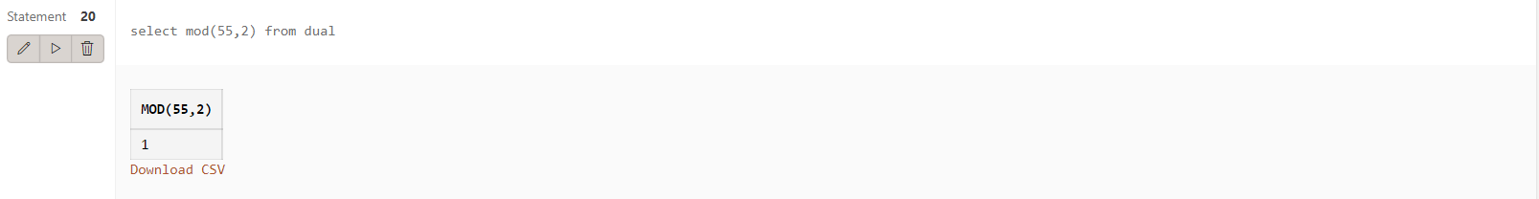

21. power(x ,y):

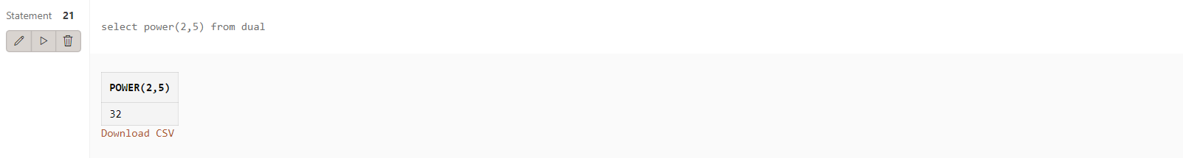

22. round(x [,y]):

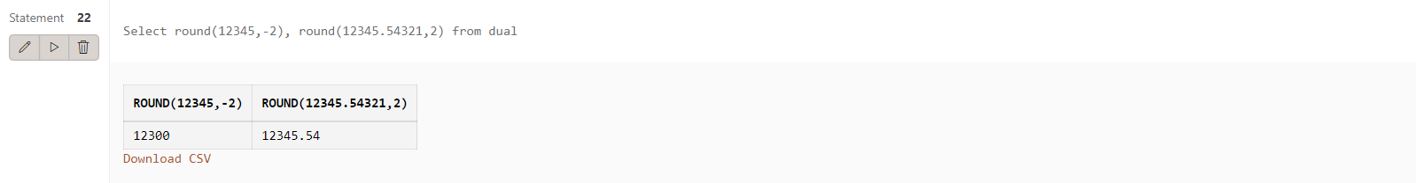

23. sign(n):

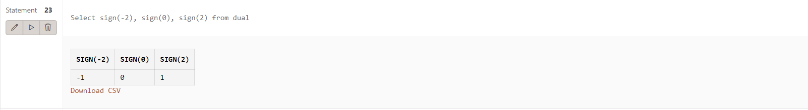

24. sqrt(n);

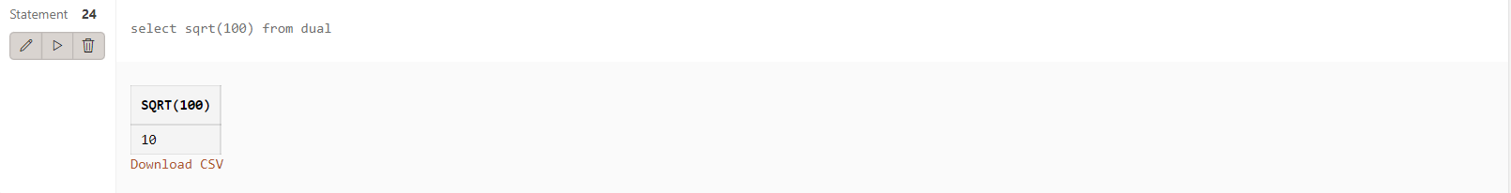

25. trunc(x ,n):

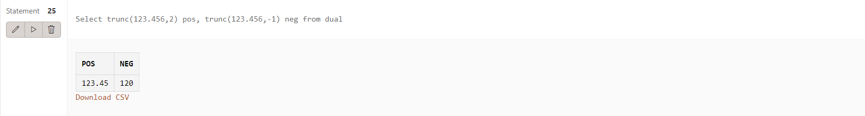

26. sysdate:

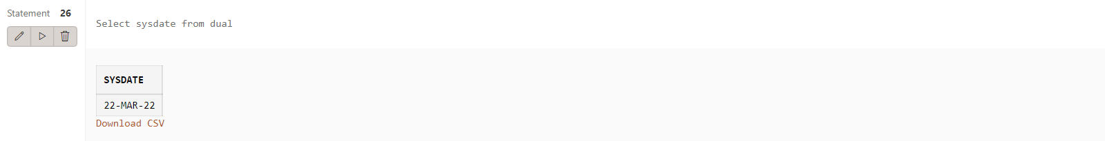

27. add_months(d ,n):

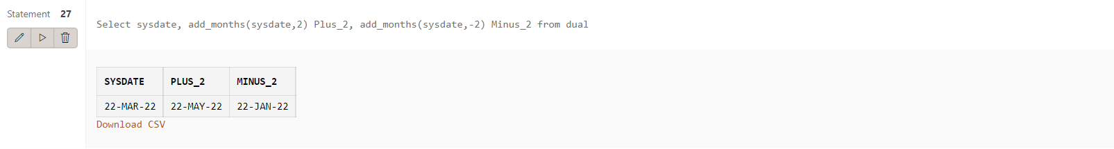

28. last_day():

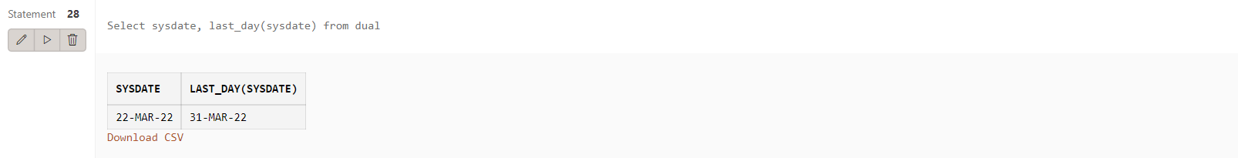

29. months_between(date1 ,date2):

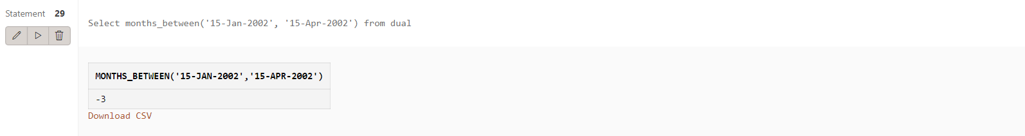

30. next_day(date ,char):

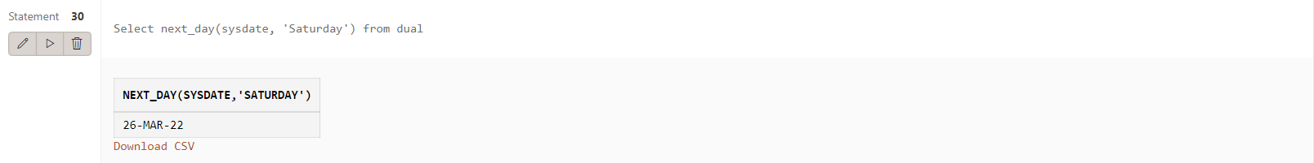

31. greatest(expr):

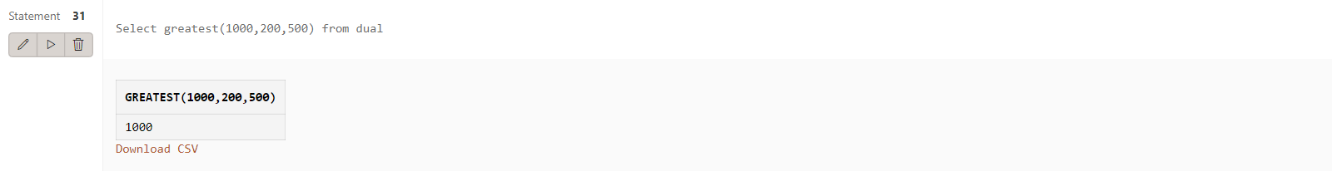

32. least(expr):

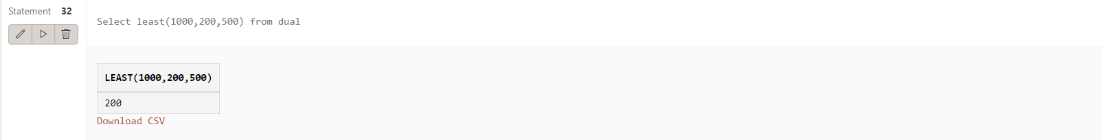

Q2) Display current time in hour : min : sec format

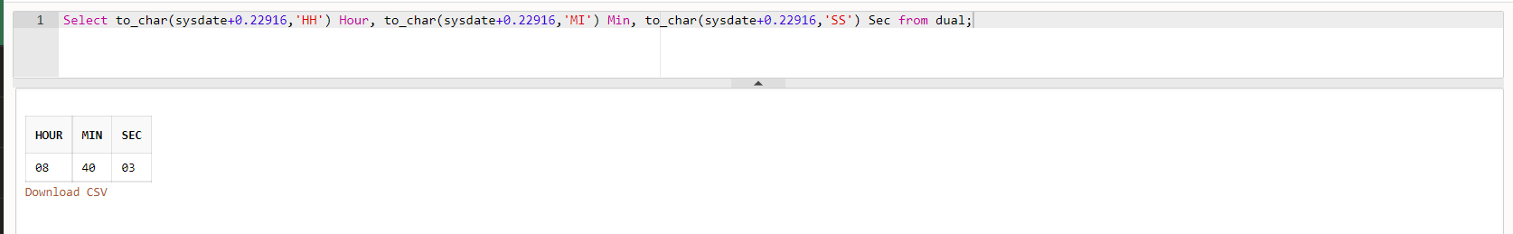

Q3) Display salary + commission of emp table

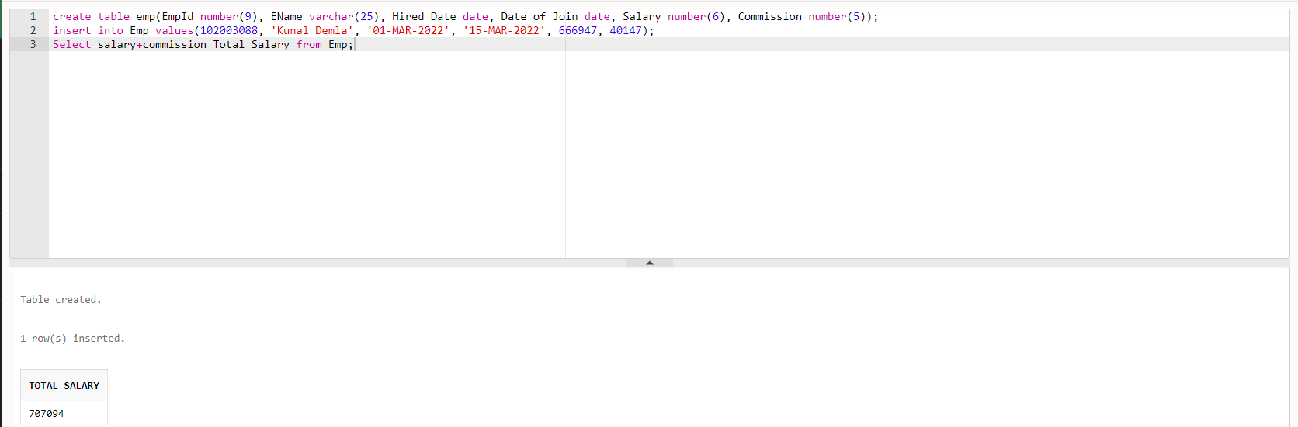

Q4) Store any date value in hiredate column of table ?

Insert into Emp(Hired_Date) values('27-Feb-2022');

Q5) Display name of employee(s) who join the company in 1985 ?

Select EName from Emp where to_char(Date_of_Join,'YYYY')=1985;

Q6) Display name of the employee(s) who join the company this year ?

Select EName from Emp where to_char(Date_of_Join,'YYYY')=to_char(SYSDATE,'YYYY');

Assignment 5

1. Create table emp which has the following attributes (employee table) (@empno, ename, job, sal, deptno) Where empno is primary key, ename is unique, job in (Prof, AP, and Lect), sal is not NULL, and deptno is foreign key

create table emp(empno number(3) primary key, ename char(30) unique, job char(30) check(job in('Prof','AP', 'Lect')), sal number(5) not null, deptno number(2) references department(deptno));

2. Create table dept which has the following attributes (department table) (@deptno, dname) Where deptno is primary key, dname in (Acc, comp, elect)

create table department(deptno number(2) primary key, deptName char(30) check(deptName in('Acc','Comp','Elec')));

3. Create table S which has the following attributes (Salesperson table) (@sno, sname, city) Where sno is primary key

CREATE TABLE S(sno number(5) primary key, sname varchar2(25), city varchar2(25));

4. Create table P which has the following attributes (Part table) (@pno, pname, color) Where pno is primary key

CREATE TABLE P(pno number(5) primary key, pname varchar2(25), color varchar2(25));

5. Create table J which has the following attributes (ProJect table) (@jno, jname, city) Where jno is primary key

CREATE TABLE J(jno number(5) primary key, jname varchar2(25), city varchar2(25));

6. Create table SPJ which has the following attributes (@ (sno, pno, jno), qty) Where combination of (sno, pno, jno) is primary key, also sno, pno, jno are foreign keys

create table SPJ(sno number(2) references S(sno), pno number(2) references P(pno), jno number(2) references J(jno), qty number(4), primary key(sno,pno,jno));

7. Insert appropriate records in above tables

Assignment 6

Q1) Check the structure of tables.

desc spj;

Q2) Check the constraint name for applied constraints?

select constraint_name, constraint_type from user_constraints where table_name = 'SPJ';

Q3) Drop the unique constraint on ENAME

alter table emp drop UNIQUE (ename);

Q4) Drop the Foreign Key constraint on DEPTNO

alter table emp drop constraint SYS_C0080234310;

Q5) Add Foreign Key constraint on DEPTNO

alter table emp add constraint fk foreign key(deptno) references department(deptno);

Q6) Change Data type of ENAME

alter table emp modify ename varchar2(45);

Q7) Change width of DNAME

alter table department modify deptName char(50);

Q8) Add COMM column in EMP table

alter table emp add comm number(4);

Q9) Drop CITY column from J table

alter table J drop column city;

Q10) Create duplicate copy of EMP table

create table new_emp as select * from emp;

Q11) Copy structure of DEPT table in another table with different column names

create table dept2 (a1,a2) as select * from DEPARTMENT;

Q12) Change the name and job of the employee whose EMPNO =100

update emp set ename='Kunal',job='AP' where empno=100;

Q14) Drop DEPT Table

drop table department cascade constraints;

Q15) Drop duplicate table of EMP table

drop table new_emp;

Assignment 7

CREATE TABLE salespeople(snum number(4) constraint ssnumpk primary key,sname varchar2(15) constraint ssnameu unique,city varchar2(20),comm number(3,2));

CREATE TABLE customers(cnum number(4) constraint ccnumpk primary key,cname varchar2(15),city Varchar2(20) constraint ccitynn not null,snum number(4) constraint csnumfk references salespeople(snum));

CREATE TABLE orders(onum number(4) constraint oonumpk primary key,amt number(6,2),odate date,cnum number(4) constraint ocnumfk references customers(cnum),snum number(4) constraint osnumfk references salespeople(snum));

INSERT INTO salespeople VALUES(1001, 'Peel', 'London', 0.12);

INSERT INTO salespeople VALUES(1002, 'Serres', 'Sanjose', 0.13);

INSERT INTO salespeople VALUES(1004, 'Motika', 'Landon', 0.11);

INSERT INTO salespeople VALUES(1007, 'Rifkin', 'Barcelona', 0.15);

INSERT INTO salespeople VALUES(1003, 'Axelrod', 'Newyork', 0.10);

INSERT INTO customers VALUES(2001, 'Hoffman', 'London', 1001);

INSERT INTO customers VALUES(2002, 'Giovanni', 'Rome', 1003);

INSERT INTO customers VALUES(2003, 'Liu', 'Sanjose', 1002);

INSERT INTO customers VALUES(2004, 'Grass', 'Berlin', 1002);

INSERT INTO customers VALUES(2006, 'Clemens', 'London', 1001);

INSERT INTO customers VALUES(2008, 'Cisneros', 'Sanjose', 1007);

INSERT INTO customers VALUES(2007, 'Pereira', 'Rome', 1004);

INSERT INTO orders VALUES(3001, '18.69', '3-Oct-1990', 2008, 1007);

INSERT INTO orders VALUES(3003, '767.19', '3-Oct-1990', 2001, 1001);

INSERT INTO orders VALUES(3002, '1900.10', '3-Oct-1990', 2007, 1004);

INSERT INTO orders VALUES(3005, '5160.45', '3-Oct-1990', 2003, 1002);

INSERT INTO orders VALUES(3006, '1098.16', '3-Oct-1990', 2008, 1007);

INSERT INTO orders VALUES(3009, '1713.23', '4-Oct-1990', 2002, 1003);

INSERT INTO orders VALUES(3007, '75.75', '4-Oct-1990', 2004, 1002);

INSERT INTO orders VALUES(3008, '4273.00', '5-Oct-1990', 2006, 1001);

INSERT INTO orders VALUES(3010, '1309.95', '6-Oct-1990', 2004, 1002);

INSERT INTO orders VALUES(3011, '9891.88', '6-Oct-1990', 2006, 1001);

1) Count the number of Salesperson whose name begin with ‘a’/’A’.

SELECT COUNT(sname) FROM salespeople where sname like 'a%' or sname like 'A%';

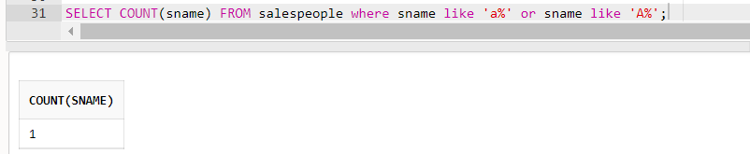

2) Display all the Salesperson whose all orders worth is more than Rs. 2000.

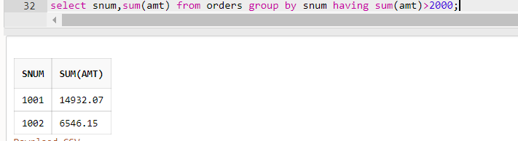

3) Count the number of Salesperson belonging to New York.

SELECT COUNT(sname) FROM salespeople where city='London';

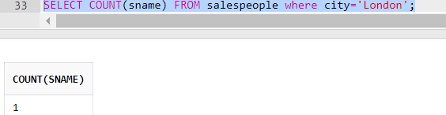

4) Display the number of Salespeople belonging to Landon and belonging to Paris.

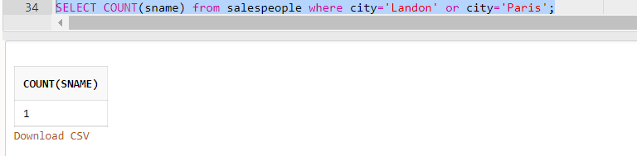

5) Display the number of orders taken by each Salesperson and their date of orders.

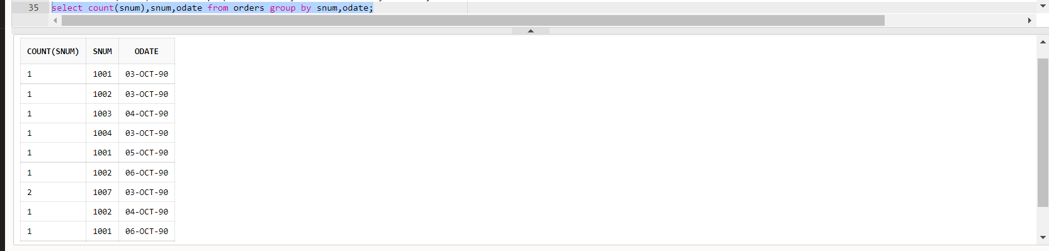

6) Write a query that counts the number of Salespeople registering orders for each day.

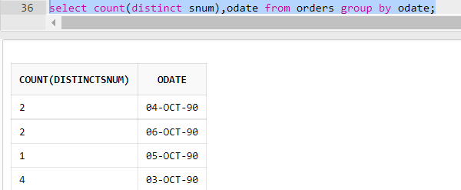

7) Write a query that selects the first customer in alphabetical order , whose name begins with ‘G’.

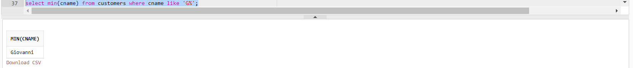

8) Find out the largest orders for Snum 1002 & 1007.

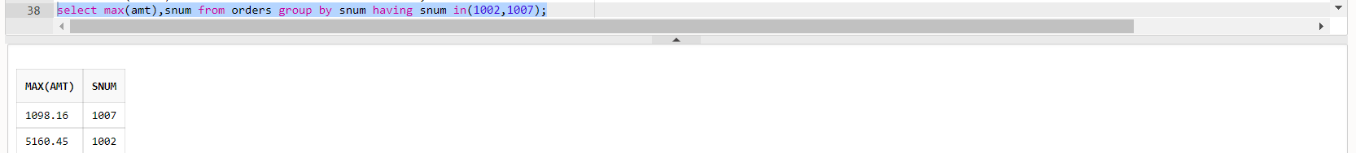

9) Find out the maximum single order amount of a Salesperson over Rs. 3000 in a day.

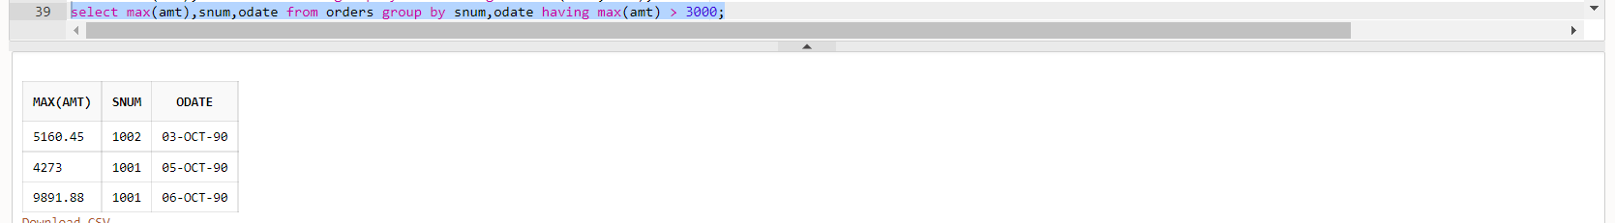

10) Find out the no. of Salesperson who belongs to same city and have same commission percentage

